NVPS-1524F1A-Q370
Network Video Recorder (NVR) (1U)
Integrated with Managed PoE Switch

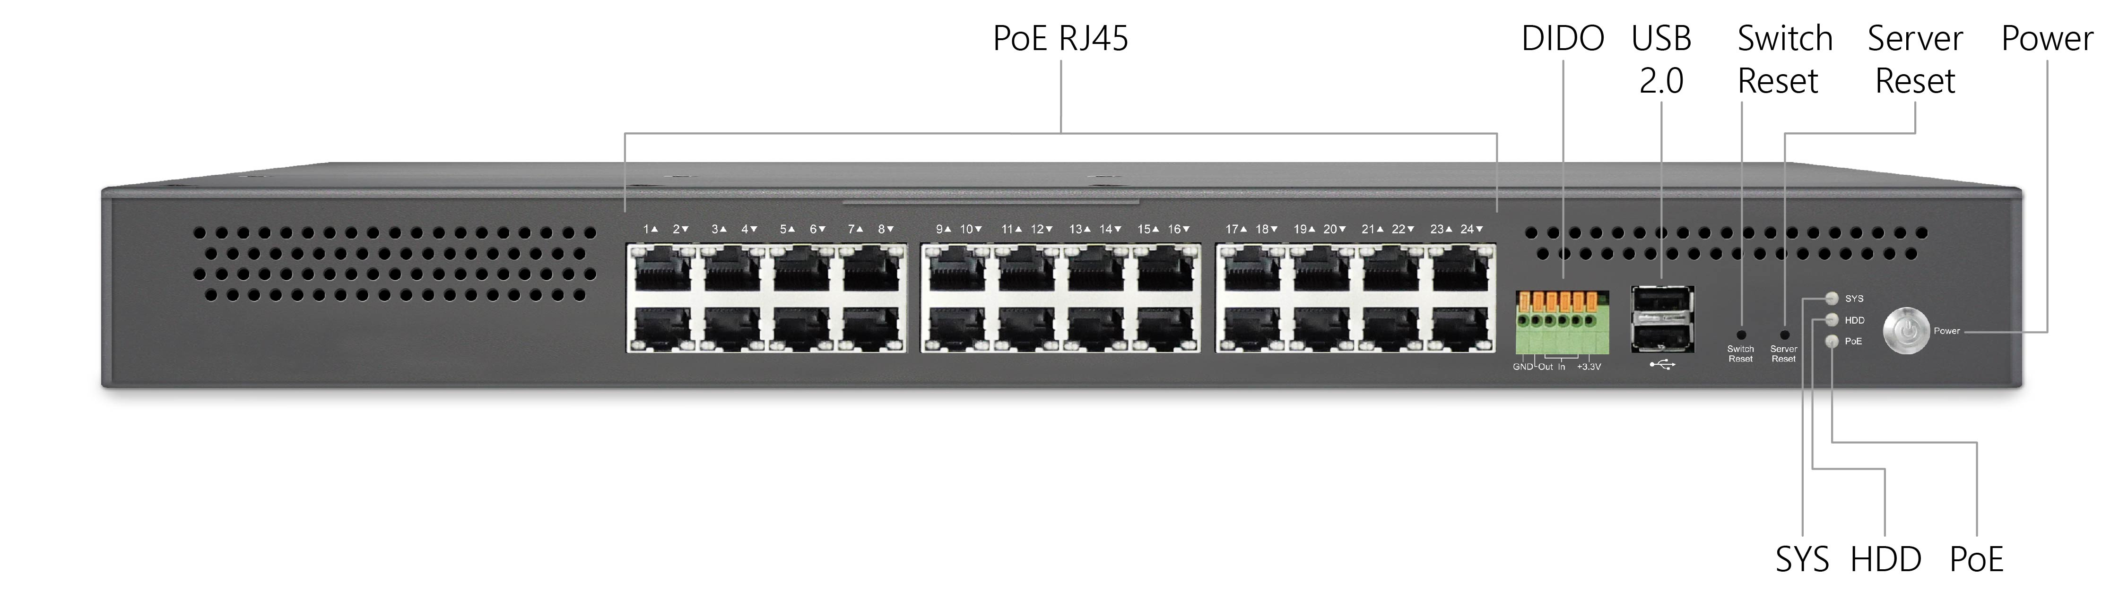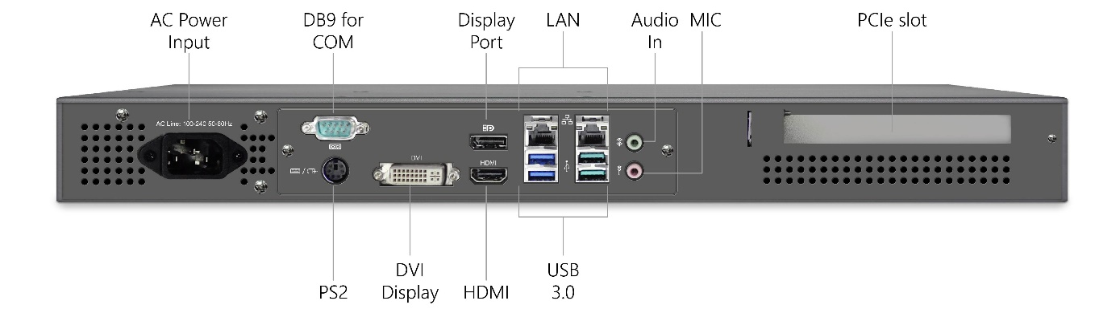
Overview
NVPS-1524F1A-Q370 is an advanced NVR device integrated with managed PoE switch for IP surveillance applications.
NVPS-1524F1A-Q370 has validated hardware components/subsystems and advanced PoE management platform to provide a cost-effective plus added value of recording and video management solution, can be loaded with various VMS/OS.
NVPS-1524F1A-Q370 is ideal to deliver management simplicity, intuitive user experience, and lower total cost of ownership. The embedded Device Managed System is designed to be extremely easy-to-use/manage/integrate for IP-Cam Applications.
Key Features
- Support microATX motherboard, various CPU can be selected
- Support internal HDD bracket, maximum 2x HDDs can be installed by user.
- Supports surveillance up to 4K video resolution
- Can be loaded with various Video Management Software
- Can be loaded with various OS
- L2+ Managed features provide easier manageability, robust security and QoS.
- Built in Device Management System (DMS)
- Support API customization for various VMS or applications
- All-in-one solution with integrated 16 ports PoE+ switch (802.3af/at)

Benefits
- Modular, Flexible, and Customizable Architecture
Support modular motherboard/switchboard type of building blocks, and it is designed to support various microATX/miniITX motherboards, power supplies, HDD access form factors. Flexibility to support various types of CPU, memory, OS, I/O expansion, and PoE features. Customization of NVR hardware and switch API firmware to optimize the benefits and to enhance the competitive differentiation for customers.

- Easy to Install, Configure and Troubleshoot by Device Management System
The DMS provides embedded functions to facilitate devices management at anytime and anywhere. Its user-friendly interface helps users to manage devices intuitively.
It supports IP-camera for end users to enhance manageability and save time/cost during installation/maintenance stages.

Specification
Server Subsystem
CPU | Intel® Core™ i3-8100  (8th/9th Gen. i5, i7, or Pentium®/Celeron® per request)
RAM | 8GB DDR4 DIMM (up to 128GB per request)
Operating System | Linux Ubuntu 18.04  (Win 10 IoT Enterprise, Win Server 2019 per request)
Network Interface | Motherboard: 2 x 1 GbE RJ45 (LAN 1/2)
Expansion Slots | 1 x M.2 2242/2260/2280 M key
Display | 1 x HDMI, 1 x DVI-I (DVI-D signal), 1 x DP++
USB | 4 x USB3.1, 4 x USB2.0, 2 x USB2.0 internal
COM | 1x DB9 (support RS-232/422/485) on rear panel
Digital I/O | DI(Input) x4, DO(Output) x1

Storage Subsystem
Number of HDD | 2 x 3.5’ HDD (Top Access), HDDs to be installed by customers
RAID Support | RAID 0/1/5/10 (Intel® Rapid Storage Technology)
VMS/OS Storage | 16GB M.2 SSD (up to 256GB M.2 SSD per request)

Network Switch Subsystem
Network Interface | 24 ports GbE RJ45 with PoE Max. 370W
Network Management | DHCP Server/Client, NTP, HTTPs, Telnet (CLI), Syslog, Device Management System (DMS), API Management
Security | SSH, SSL, IEEE 802.1X, IGMP-RADIUS, Dynamic VLAN, Layer 2 Private VLAN, Port Security, IP Source Guard, RADIUS/ TACACS+, Storm Control, DHCP Snooping, Loop Protection
Protocols | IPv6, DHCP, IGMP & MLD v1/v2 Snooping, Multicast VLAN Registration (MVR), IEEE 802.1ab (LLDP), UPnP, SNMP, Remote Monitoring (RMON)
Power over Ethernet (PoE) | Port Configuration, PoE Scheduling, Auto-checking, Power Delay

Power System
Power Input | 100~240V, 50/60 Hz
Max. Power | ATX PSU 300W, PoE PSU 450W
PoE Power Budget | Max. available PoE power: 370W  Port 1 - 24 support PoE+ (802.3at)/ PoE (802.3af)

General Specification
Operating Temperature | 0⁰ - 50⁰ C / 32⁰ - 122⁰ F
Storage Temperature | -20⁰ - 70⁰ C / -4⁰ - 158⁰ F
Humidity | 10 – 90% relative humidity (non-condensing)
Regulatory Compliance | CE (class A with LVD EN62368-1); FCC (class A); Others per request.
Form Factor | Standalone/ 1U rack & wall-mount
Dimension | 438x44x548mm (WxHxD)
Weight | Approx. TBD kg / TBD lbs (without HDD)
Hardware Warranty | 2 years (Optional 5 years per request)

